Social Perception of NFL Games: Analyzing Fan
Engagement and Sentiment in Response to Game Score
Dynamics
Elisabeth Kollrack

Undergraduate Honors Thesis Proposal
Department of Mathematics and Statistics
College of Engineering & Mathematical Sciences
The University of Vermont
Thesis Committee: Chris Danforth and Peter Dodds
May 2025

Abstract
This research will explore how NFL game characteristics, such as total score and point differential, influence fan engagement and emotion. Engagement will be tracked using the volume of tweets and retweets, and emotion will be quantified by analyzing word usage, e.g., with the Hedonometer. This thesis will be exploring the kinds of games people enjoy and would prefer to watch. Two specific shapes of games of interest are close games where the team that is winning switches frequently, i.e. “nailbiters”, and lopsided contests where one team is establishes an early lead that continues to widen throughout, i.e., “blowouts”. We also plan to explore how fans feel about these different kinds of games. I am interested in finding out if there is a certain type of game that fans prefer to win or lose. Engagement will be explored by analyzing the volume of attention as a function of total score and score differential and sentiment will tracked using the happiness scores of game related Tweets. The Tweets that are discussing a certain game are usually in the format of #Team1vsTeam2. This notation will be used when collecting data.
This thesis aims to figure out what kinds of games fans prefer to watch and win.

Literature Review
As background research for this project, I read a number of recent scientific studies that aim to quantify attention to real-world phenomenon through online proxy data. Some of these studies are described in this section of the proposal.
Storywrangler is a language processing tool used to analyze Twitter data that can track sociolinguistic and cultural trends (Alshaabi et al., 2021). The system analyzes billions of tweets and allows one to explore word popularity, cultural shifts, and social amplification. Tweets are broken up into n-grams (sequences of words) and analyzed by frequency, rank, and amplification. My research will use a similar approach, as it will search for Twitter hashtags (team names) and track their frequencies. Storywrangler has been previously used to analyze social movements
(#BlackLivesMatter, # MeToo) as well as politics, Covid-19, and popular culture. Storywrangler provides useful insights for learning more about human communication dynamics (Alshaabi et al., 2021).
This methodology can be used to analyze attention dynamics of different types of events. Arnold et al. (2021) used this method in a research project that examined tweets involving the names of hurricanes and compared public attention on social media to the severity of the hurricanes. The key findings from this research are that stronger hurricanes generate more engagement, regardless of the death toll. Also, storms in the continental United States generated much more engagement than places like Puerto Rico. The main takeaway from this research is that Twitter engagement can influence the response to natural disasters and the funding and aid they receive (Arnold et al., 2021).
Twitter is also used for real-time for event detection. Authors Sakaki et al. (2010) created a Support Vector Machine to track tweets based off keywords and context that can be a helpful early indicator of events. Filters are also used to track the location and severity of the events. Event tracking could be helpful in my research to determine which team the author of the Tweet likely supports. When implemented in Japan, earthquakes of seismic intensity 3 or higher were detected by the algorithm. Some of the time this system could detect earthquakes faster than the Japan Meteorological
Agency (Sakaki et al., 2010).
Twitter is a key platform for social medial engagement in the context of sports. Einsle et al. (2023) researched how user interaction such as likes, comments, and shares boost fan engagement. By having the ability to retweet and reply, fans can interact with each other in real time and quickly share updates about the game. Social media allows for fans to be connected and not miss out on major events if they are not watching the game live. Fear of Missing Out (FoMO) leads to Continuous
Partial Attention (CPA) where fans interact on social media while watching games (Lee & Na, 2024). Twitter is especially useful for aggregating discussions about sporting events because hashtags help organize conversations and make trending topics more visible (Einsle et al., 2023).
Smith et al. (2019) researched the differences in fans who Tweet during the game versus fans who Tweet after the game. The study explores how Twitter use affect fans’ enjoyment and outcomes of events and how using Twitter as a second screen plays a role. The authors found that fans who used Twitter while watching the game seemed to enjoy the game more than someone who just read the tweets. They also found that fans who interact with each other online were more interested in the game and enjoyed it more. The results from this study suggest that Twitter interaction provide fans with a sense of community, which enhances enjoyment (Smith et al., 2019).
A study by Chierichetti et al. (2014) used real time event data to look at how large populations responded to major events like the Super Bowl, award shows, and the World Cup. These events are detected by looking at tweet volume and recent activity. The authors found that during the game, original tweets increase and replies and retweets decrease. After a game, the opposite is true and retweets and replies are more common. The researchers used a logistic regression classifier to detect events and a probabilistic model to differentiate between general tweeting and event-based tweeting (Chierichetti et al., 2014). It is important for my research to ensure I am tracking tweets that refer to the game and not all tweets that happen to be posted during the game’s span.
Corney et al. (2014) did similar research and used word frequency is used to see what topics are popular. The study focused on FA Cup finals and looked at significant moments in those matches. Their system used clustering to detect significant moments and even moments that happened during overlapping events. They were even able to distinguish different teams’ fans and how they react differently to the same event. Their methods could successfully detect most major events (goals and saves) from the world cup finals (Corney et al., 2014).
Australian Rules Football (AFL) games were examined to analyze their scoring patterns and game stories (Kiley et al., 2016). These scoring dynamics were compared to random walk models. The motifs studied that were the most common include last-minute comebacks, one-sided blowouts, and back and forth scoring. Compared to the random walk models, AFL games were much more diverse and interesting. The authors then studied their ability to make predictions on the final outcome based on the scoring patterns. They found that score differential is helpful in making accurate predictions, but the full history of scoring is not (Kiley et al., 2016). My research will also explore different game narratives and attempt to compare them to fan reactions.
Twitter data is used to measure societal happiness over a period of time. Dodds et al. created a hedonometer device to give happiness scores based off words used. The hedonometer found that the “happiest” day of the week is Saturday and the “saddest” is Tuesday. Holidays are some of the happiest days, while natural disasters and celebrity deaths cause happiness scores to decrease. This metric analyzes how key words such as “love” and “food” are some of the happier words and “hate” and “funeral” are some of the saddest words. The hedonometer can be used as a real-time tracker of mood for populations as well as event detection and the public responses to different events (Dodds et al., 2011). This instrument will be especially helpful when trying to determine how fans react to different types of games.
One of my research questions is focused on how people feel about different types of wins. Meng et al. ( 2016) did a study about one’s motivation to win and how different levels of challenge affect intrinsic motivation. Participants competed in two matches online StopWatch (SW) matches and won one of them by a large margin and one by a small margin. Electrophysiological data was used to measure intrinsic motivation. The study found that participants were more motivated to win if the score was close and the data showed that they seemed more engaged. These results support the SelfDetermination Theory that explains how the optimal challenge significantly increases motivation. In another experiment, authors analyzed two studies where in the first one, participants played video games where the score differential was manipulated (Abuhamdeh et al., 2015). They found that greater uncertainty led to more enjoyment than winning by a large margin, due to the suspense of a close game. The second study had participants play two games, one that ended in a close game and one that was not. The participants then chose which game to replay, and most chose the close game. The result from these studies proves that outcome uncertainty and close competition enhances enjoyment and motivation (Abuhamdeh et al., 2015; Meng et al., 2016).

Thesis Questions
The objective of this thesis is to analyze National Football League (NFL) game engagement data to determine which factors impact fan engagement. Specifically, this research aims to address the following questions: (a) How does total score impact volume of attention? (b) How does score differential impact volume of attention? (c) Does the score differential affect the sentiment of the fans’ tweets?

Methodology
This thesis will be carried out using a computational approach. Data will be obtained from the Vermont Advanced Computing Center. I plan to begin pulling data in May 2025 and complete my data collection by November 2025. First, I will need to clean the data I’m using and make sure the Tweets were authored by people, not bots. I will be looking at both volume of Tweets and sentiment of Tweets. The Tweets will be identified by the use of “#Team1vsTeam2” or similar statements in the posts. Data cleaning will also be important for this step in order to account for misspellings. I will first look at how the volume of attention varies based on factors such as total score, score differential, score changes, date, week, duration of game, and time of day. Gaining insight on these patterns will help me identify which other kinds of relationships are worth looking into.

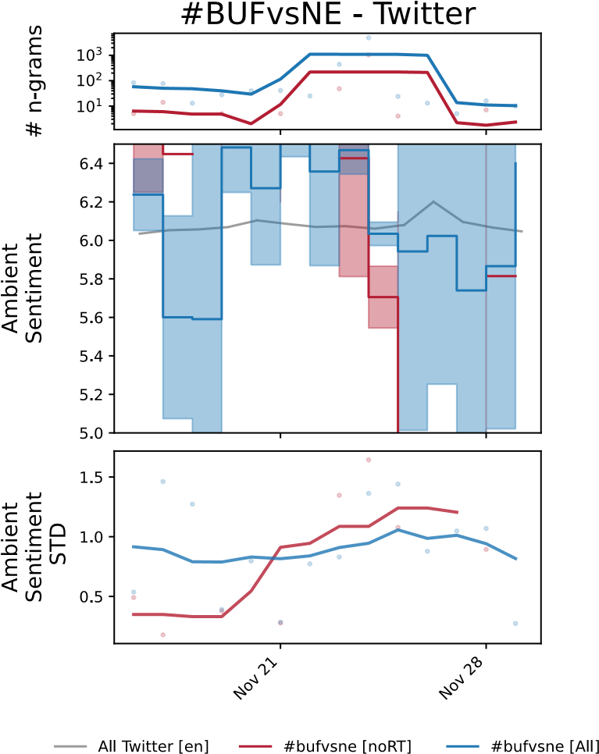
Figure 1. This graph shows the count of n-grams and sentiment analysis for the tweets
“#BUFvsNE” (case-insensitive) published between November 16, 2015, and November
30, 2015. The Buffalo Bills played the New England Patriots (in Massachusetts) on November 23, 2015. There is a clear spike in the number of tweets from November 21 until around November 27, likely due to people continuing to discuss the game after it occurred.
After exploratory data analysis is done, patterns will be further explored through linear regression analysis and a classification model (likely random forests or XGBoost). This will help find the important features in predicting volume of attention. If time permits, I will investigate time-series techniques to see how attention varies throughout a game (alignment of Tweets and play-by-play data).
Next, I plan to explore the sentiment of these Tweets. The goal of this thesis is to figure out what kinds of games people prefer to watch and what kinds of games people prefer to win or lose. In this case, emotion is quantified by analyzing word usage. If time and resources permit, I will explore the happiness across fanbases (by using location data). This will be able to better pinpoint which fan groups are happy about the game’s outcome and which fanbases are upset about the outcome. However, since some fanbases are significantly larger than others, fanbase size will need to be normalized. To analyze this data, I can train a machine learning model such as a support vector machine or a statistical modeling technique to categorize game score differential with having a positive or negative online reaction.
Another important element of this research are possible errors in data collection. This could happen if more people Tweeted about a certain game due to a major play or statistical milestone, not due to the game’s score or number of score changes. A popular player (e.g. Tom Brady, Patrick Mahomes) could also influence attention. These factors should be explored before too much data analysis is done.

Timeline
Tasks
August
September
October
November
December
January
February
March
April
May
Data Collection
Examine relationships: volume of attention
vs game score shape (in game and post
game)
Examine post game sentiment
relationships
Analyze results and explore more
relationships if needed
Write thesis
Finalize thesis and presentation
Present at UVM Computational Story Lab's
Story Time
Present thesis to committee
Revise thesis
Honors College Thesis Completion Form
and Advisor Permission for Submission to
ScholarWorks
Fig. 2 – Gantt Chart

References
Abuhamdeh, S., Csikszentmihalyi, M., & Jalal, B. (2015). Enjoying the possibility of defeat:
Outcome uncertainty, suspense, and intrinsic motivation. Motivation and Emotion, 39(1), 1–
10. https://doi.org/10.1007/s11031-014-9425-2
Alshaabi, T., Adams, J. L., Arnold, M. V., Minot, J. R., Dewhurst, D. R., Reagan, A. J., Danforth, C. M., & Dodds, P. S. (2021). Storywrangler: A massive exploratorium for sociolinguistic, cultural, socioeconomic, and political timelines using Twitter. Science
Advances, 7(29), eabe6534. https://doi.org/10.1126/sciadv.abe6534
Arnold, M. V., Dewhurst, D. R., Alshaabi, T., Minot, J. R., Adams, J. L., Danforth, C. M., & Dodds, P. S. (2021). Hurricanes and hashtags: Characterizing online collective attention for natural disasters. PLOS ONE, 16(5), e0251762. https://doi.org/10.1371/journal.pone.0251762
Chierichetti, F., Kleinberg, J., Kumar, R., Mahdian, M., & Pandey, S. (2014). Event Detection via Communication Pattern Analysis. Proceedings of the International AAAI Conference on
Web and Social Media, 8(1), 51–60. https://doi.org/10.1609/icwsm.v8i1.14536
Corney, D., Martin, C., & Göker, A. (2014). Spot the Ball: Detecting Sports Events on Twitter.
In M. De Rijke, T. Kenter, A. P. De Vries, C. Zhai, F. De Jong, K. Radinsky, & K.
Hofmann (Eds.), Advances in Information Retrieval (Vol. 8416, pp. 449–454). Springer
International Publishing. https://doi.org/10.1007/978-3-319-06028-6_40
Dodds, P. S., Harris, K. D., Kloumann, I. M., Bliss, C. A., & Danforth, C. M. (2011). Temporal
Patterns of Happiness and Information in a Global Social Network: Hedonometrics and
Twitter. PLoS ONE, 6(12), e26752. https://doi.org/10.1371/journal.pone.0026752
Einsle, C.-S., Escalera-Izquierdo, G., & García-Fernández, J. (2023). Social media hook sports events: A systematic review of engagement. Communication & Society, 36(3), 133–151.
https://doi.org/10.15581/003.36.3.133-151
Hedonometer. (n.d.). Retrieved March 12, 2025, from https://hedonometer.org/timeseries/en_all/?from=2021-12-30&to=2023-06-29
Kiley, D. P., Reagan, A. J., Mitchell, L., Danforth, C. M., & Dodds, P. S. (2016). Game story space of professional sports: Australian rules football. Physical Review E, 93(5), 052314. https://doi.org/10.1103/PhysRevE.93.052314
Lee, Y., & Na, S. (2024). Fear of Missing Out: An Antecedent of Online Fan Engagement of
Sport Teams’ Social Media. Communication & Sport, 12(5), 908–937.
https://doi.org/10.1177/21674795231174565
Meng, L., Pei, G., Zheng, J., & Ma, Q. (2016). Close games versus blowouts: Optimal challenge reinforces one’s intrinsic motivation to win. International Journal of Psychophysiology,
110, 102–108. https://doi.org/10.1016/j.ijpsycho.2016.11.001
Sakaki, T., Okazaki, M., & Matsuo, Y. (2010). Earthquake shakes Twitter users. Proceedings of the 19th International Conference on World Wide Web, 8–860.
https://doi.org/10.1145/1772690.1772777
Smith, L. R., Pegoraro, A., & Cruikshank, S. A. (2019). Tweet, Retweet, Favorite: The Impact of
Twitter Use on Enjoyment and Sports Viewing. Journal of Broadcasting & Electronic
Media, 63(1), 94–110. https://doi.org/10.1080/08838151.2019.1568805

